Phase 1: Problem Understanding & Industry Analysis
Project: Smart City Citizen Helpdesk & Engagement Platform
A comprehensive study of city issues, stakeholder needs, and Salesforce-based solution opportunities for citizen engagement and real-time problem resolution
Prepared by: B. V. Manasa

1. Requirement Gathering
The Smart City Citizen Helpdesk aims to provide a single platform for citizens to report, track, and receive updates for all city issues, including streetlights, potholes, water leakage, accidents, waste management, traffic problems, and health emergencies.
Requirement ID | Description | Priority | Source
R1 | Citizens should be able to report issues via mobile app, portal, WhatsApp | High | Stakeholder / Market Research
R2 | Citizens receive real-time updates for each complaint | High | Stakeholder
R3 | Complaints automatically routed to the correct department | High | Industry Best Practice
R4 | Heatmap dashboard for city officials | Medium | Industry Analysis
R5 | AI prediction for emergency prioritization | Medium | Market Benchmark

2. Stakeholder Analysis
The project involves multiple stakeholders including citizens, city staff, field officers, and city managers.
Stakeholder Table:
Stakeholder | Role | Needs | Interaction with System
Citizen | Report issues | Fast response, updates | Portal, Mobile App, WhatsApp
Field Officer | Resolve complaints | Assigned tasks, location info | Salesforce Field Service Lightning
City Admin | Monitor city issues | Dashboard, KPI tracking | Salesforce Lightning Dashboard
Department Head | Supervise team | SLA management, reports | Reports, Automation Alerts

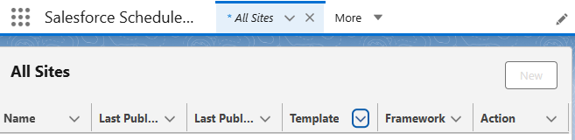
Experience Cloud portal template for citizen issue reporting

3. Business Process Mapping
Process Flow:
- Citizen reports an issue (streetlight, pothole, accident, water leakage, etc.)
- Salesforce creates a Case
- Einstein AI categorizes and prioritizes the issue
- Case is auto-routed to the correct department/field officer
- Field officer resolves the issue
- Citizen receives real-time updates (acknowledgment → assignment → in-progress → completion → feedback)
- Case closed
Business Process Table:
Step | Actor | Action | System Involved
1 | Citizen | Reports issue | Experience Cloud / App / WhatsApp
2 | System | Case created & logged | Salesforce Service Cloud
3 | System | AI categorizes & prioritizes | Einstein AI
4 | System | Auto-route to department | Salesforce Case Assignment Rules
5 | Field Officer | Resolves issue | Field Service Lightning
6 | System | Updates citizen | Omni-Channel Notifications
7 | Citizen | Provides feedback | Experience Cloud / App

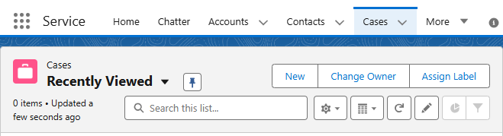
Service Cloud Cases tab showing where citizen complaints will be logged and managed

4. Industry-Specific Use Case Analysis
Use Case Table:
Use Case | Description | Real-World Example
Emergency Response | Accidents reported → auto alert ambulance/police | Smart City Vijayawada
Waste Management | IoT bins auto-report overflow → dispatch cleaning | Smart City Delhi
Streetlight Monitoring | Failed lights auto-report → maintenance crew assigned | Smart City Hyderabad

5. AppExchange Exploration
Salesforce AppExchange provides pre-built apps/templates to accelerate project development.
AppExchange Table:
App/Plugin | Purpose | Customization Needed | Notes
Field Service Lightning | Assign & track field tasks | Minimal | Standard Salesforce app
Omni-Channel Messaging | WhatsApp/SMS integration | Required for citizen updates | Salesforce-supported APIs
Experience Cloud Portal | Citizen reporting | Custom UI + gamification | Build on top of template

